Butler 201 Audio Set Up and Troubleshooting Guide

Butler 201 is set up to run audio primarily through the ClickShare device. Once the ClickShare device is downloaded onto the computer and synced (check ClickShare instructions on how to do this) you can effortlessly play audio through the speakers integrated into the room.

How to play audio through the ClickShare Dongle

- Point the Denon remote at the receive and select the “CD” input

- The receiver will read “MCH Stereo CD;” set the volume between -16 db and -20db.

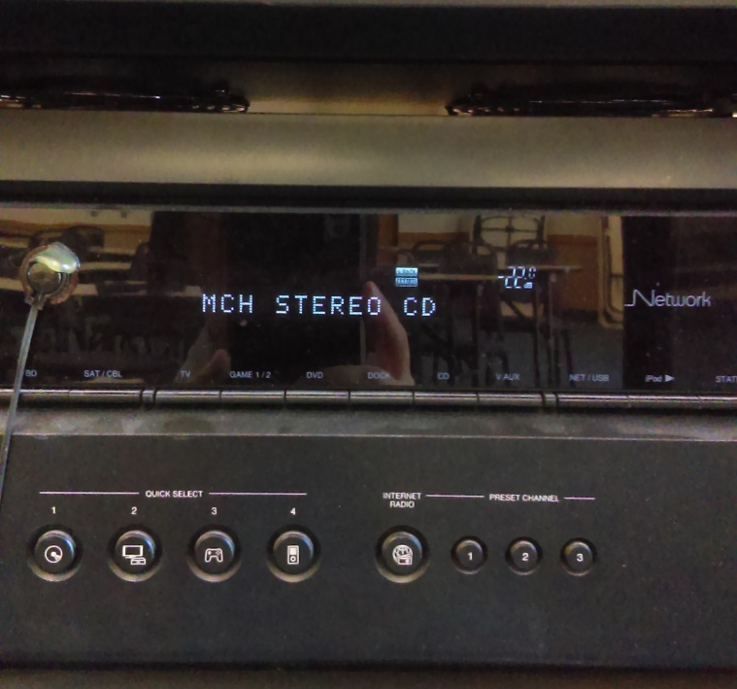

- To prevent an echo, set the TV volume to 0 using the Sharpe TV remote.

- Finally, adjust the volume on your laptop/device to an appropriate level. Audio should now be audible in the room.

Audio Troubleshooting Guide

- Set Lifesize volume to a higher level using the LifeSize remote
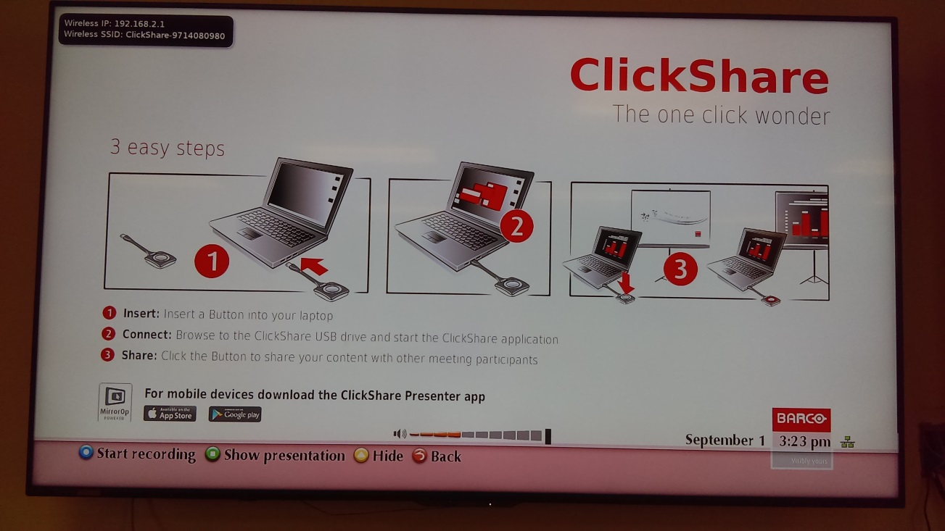
- Reestablish ClickShare Connection by unplugging the ClickShare dongle and downloading the software again
- For Mac users, you may need to select the ClickShare device on your audio output; this will notify your device to send audio out to the ClickShare system. Without completing this step your device may not understand that you want send your audio signal out of your device. Go to “System Preference,” select “Sound” to bring up your audio options, select the “Output” tab then select ClickShare for audio out.
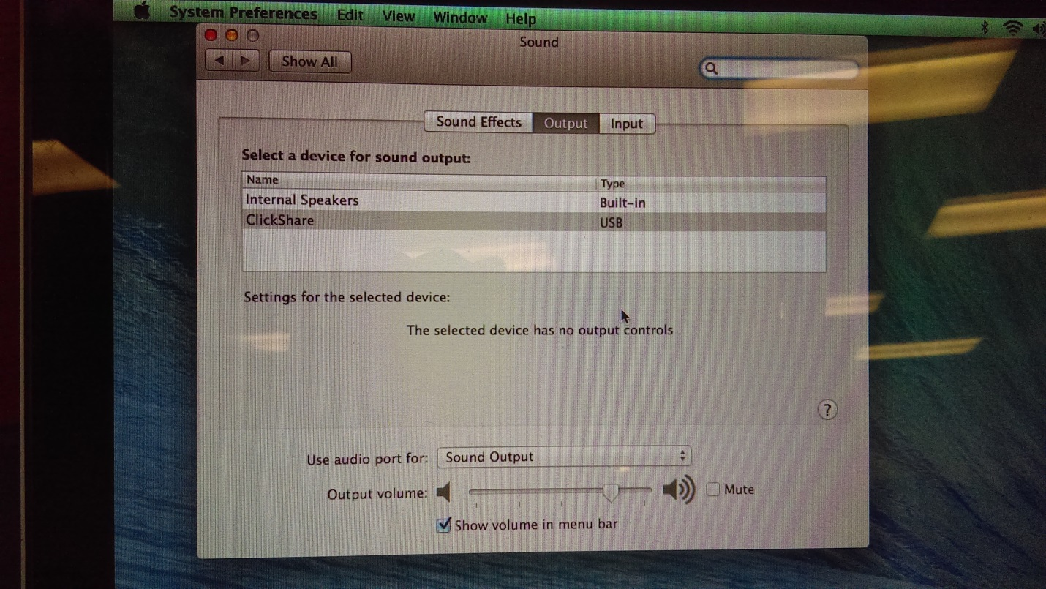
Your device will now send audio out through the ClickShare system.
- If all of the above fails, resort to a hard boot by unplugging the rack from the wall, wait 10 seconds then plug the rack back into the outlet.

If audio is still not functioning properly please call #6373 on the ShoreTel phone for Help Desk to provide the necessary assistance.

